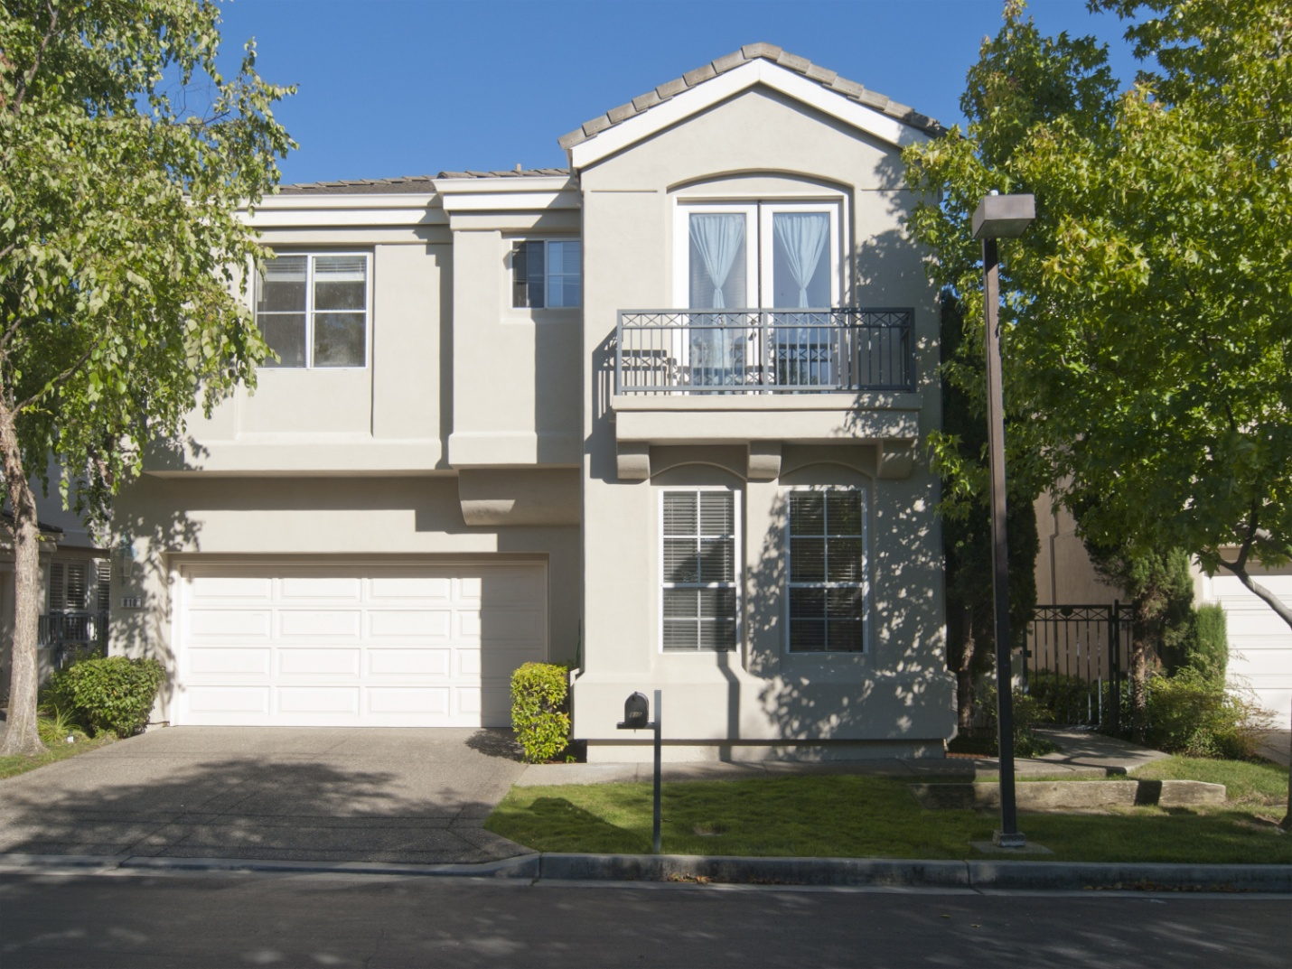
Enjoy resort style living in this bright, airy, beautifully appointed home in the Laguna Pointe development of Redwood Shores. The sun shines in all areas of this home as a gated slate front entry leads indoors to vaulted ceilings, plentiful windows, and art deco inspired detailing, adding elegance to the interior. With 4 large bedrooms including an enormous master suite, a loft, formal living, dining and family rooms, and an eat-in-kitchen: This home has all the space a family could desire. The backyard overlooks a small waterway and within a short walk is Redwood Shores Lagoon with waterfront picnic and play areas, docks and volleyball courts.

Bedrooms: 4 Bathrooms: 3 House: 2,855 sq ft Lot: 4,452 sq ft
Juliana Lee 650.857.1000 www.JulianaLee.com

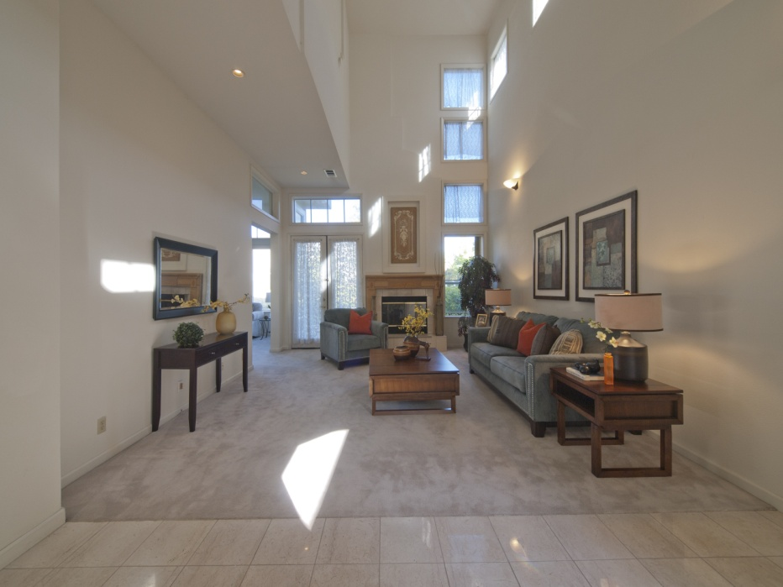
THROUGHOUT THE HOUSE
- Vaulted cathedral ceilings
- Wall to wall carpeting in most rooms
- Marble tiled flooring in entry, hallway downstairs, bathrooms and kitchen
- Recessed lighting
- Decorative wall sconces
- Large windows, French doors and accent windows
- Crown molding, decorative in-wall/ceiling detailing
- Dimmers

ENTRY
- Exterior gated door with long slate pathway to front entry
- Front door flanked on each side by tall window
- Large marble tiled foyer
- Opens to living room, dining room, hallway and staircase

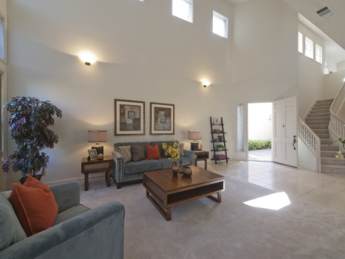

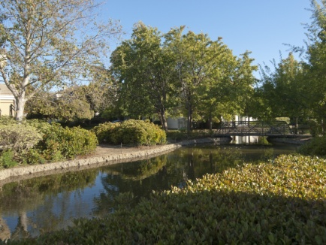
LIVING ROOM
- Fireplace with mantle
- French doors leading to backyard
- Cathedral ceiling
- Recessed lighting and wall sconce lamps
- Sunlit with accent windows

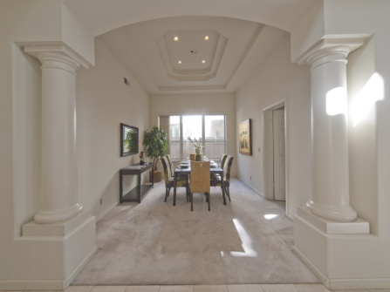
DINING ROOM
- Wide entry flanked by classical columns
- Direct access to kitchen
- Coffered ceiling
- Windows
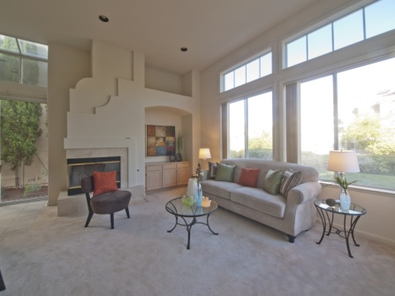
FAMILY ROOM
- Fireplace
- Overlooks kitchen
- Recessed media center in wall
- Whitewashed storage cabinetry
- Wet bar: mirrored walls, sink, solid colored Corion countertop
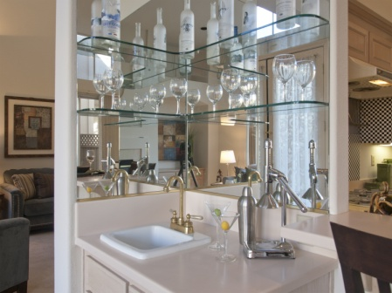
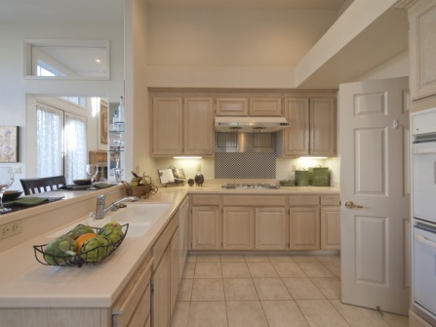
KITCHEN
- Double bowl kitchen sink with pullout spray faucet and hot water tap
- White GE appliances: double oven, dishwasher, range, microwave
- Corian countertops
- Whitewashed cabinetry
- Space for breakfast table
- Sliding glass doors leading to side yard with accent windows above and skylights
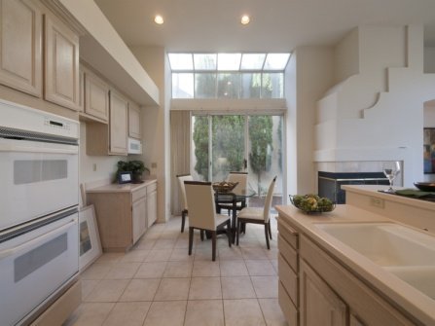

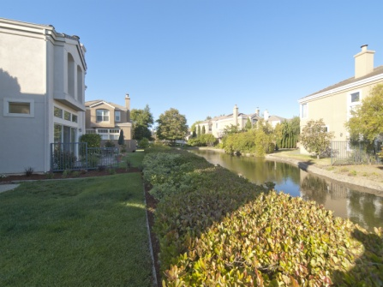
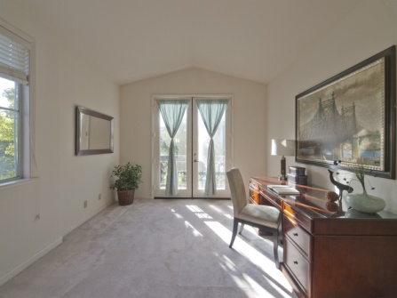
LOFT
- French doors open to small balcony
- Perfect use as office, playroom, extra bedroom

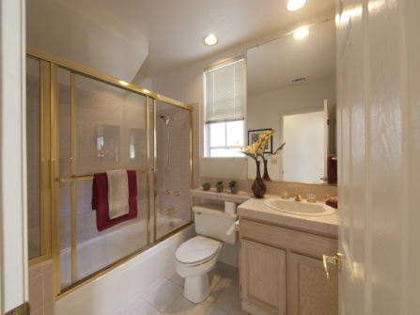
DOWNSTAIRS BATHROOM
- Full bath
- Tile floor and countertop

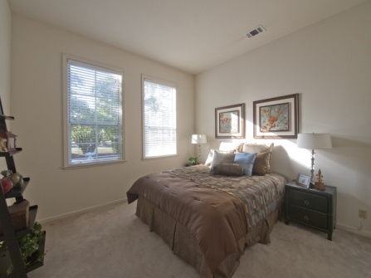
DOWNSTAIRS BEDROOM
- Mirrored closet doors
- View of front yard and green belt
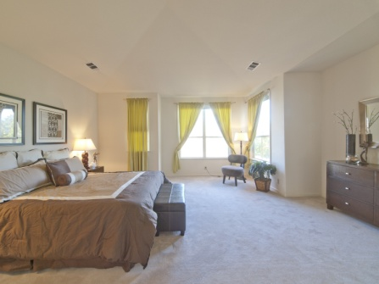 MASTER BEDROOM
- Ample size
- Two walk in closets
- Mirrored closet doors
- Sky lit hallway adjoining Master bath
- Vaulted ceiling

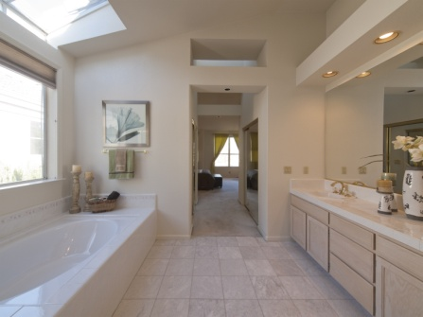
MASTER BATH
- Large oval soaking tub with adjacent window
- Separate glass walled shower
- Double sink vanity
- Tile floor and countertop
- Separate toilet stall
- Skylit
- Vaulted ceiling

GARAGE
- Side door to yard and door to interior
- Space for two cars
- Electric door opener

SECOND/THIRD BEDROOM
- Vaulted ceiling
- Mirrored closet door

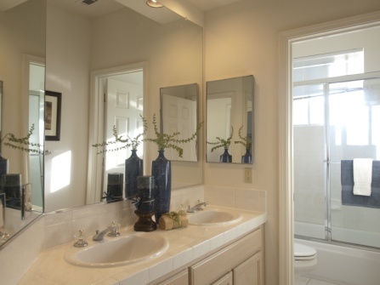
UPSTAIRS BATH
- Double sink vanity
- Tile floor and countertop



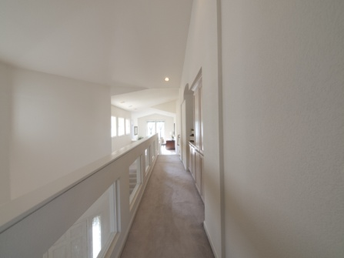
UPSTAIRS HALL
- Built in cabinetry
- Accent windows on ½ wall overlooking living room
- Laundry room off hallway

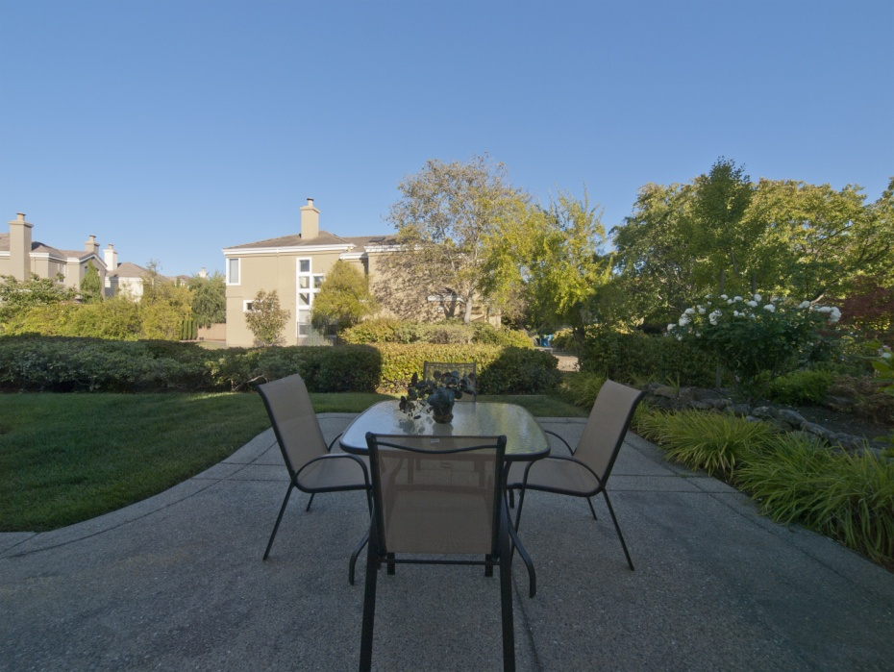
SCHOOLS
- Redwood Shores Elementary
- Ralston Middle
- Carlmont High
LAGUNA POINTE COMMUNITY
- Close walk to Redwood Shores Lagoon
- Play/picnic area
- Playground
- Boat docks
- Volleyball court
- Community pool
- Interior community creek
POINTS OF INTEREST NEARBY
- Boating/waterfront recreation
- Shorebird Park
- Redwood Shores Public Library
- Oracle headquarters



