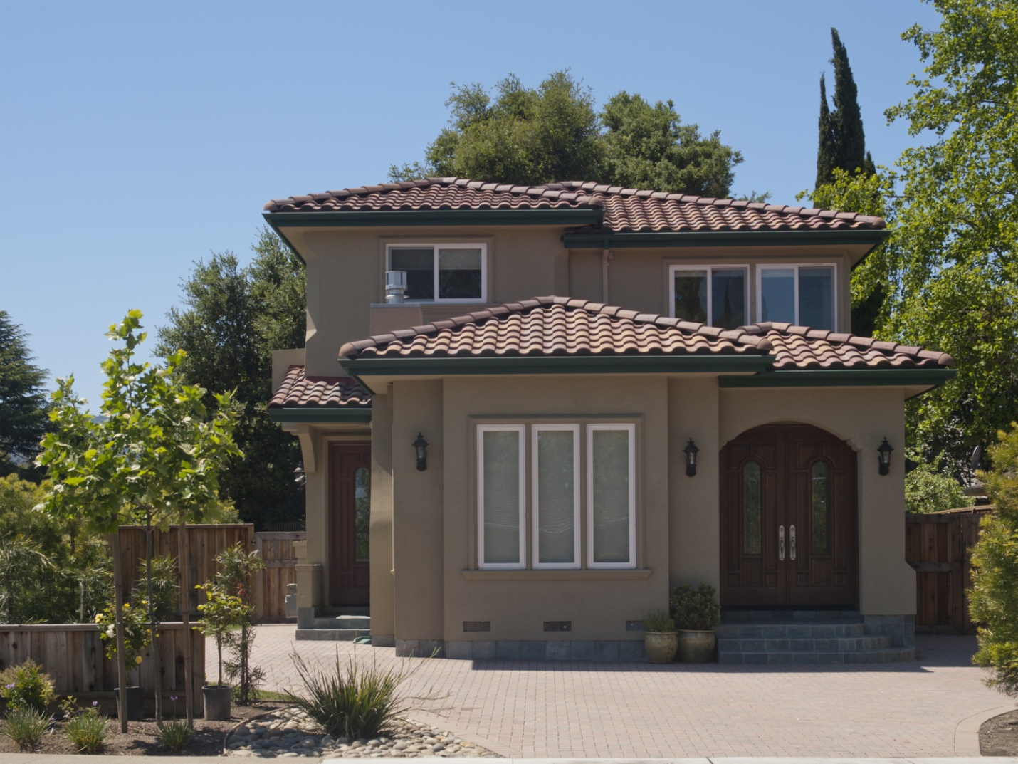
You will love living in this warm, luxurious home in the peaceful Green Acres neighborhood located on a short street having five large newer homes in one short block. The rich reddish brown hardwood floors, yellow-earth colored stone floor tiles and wall paint are complemented by gleaming white molding and faintly off-white ceilings. Outdoor walkways built from pavers and the reddish clay-style roof tiles blend the finely crafted nature of this home with the verdant outdoors.

Bedrooms: 4+ Bathrooms: 3.5 House: 2,806 sq ft Lot: 7,684 sq ft
Juliana Lee 650.857.1000 www.JulianaLee.com

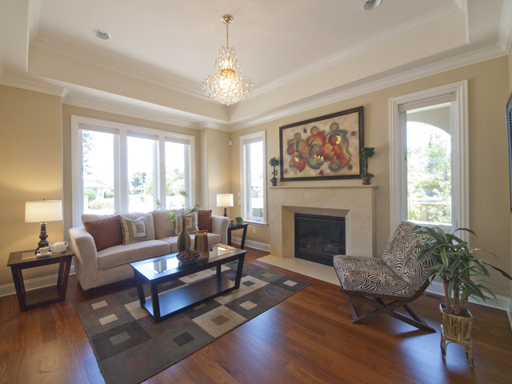
THROUGHOUT THE HOUSE
- Reddish brown hardwood floor with mahogany like fine grain and more striking large grain patterns
- Windows with translucent blinds which can partially open at top or bottom
- Gleaming white window casings, door casings, crown molding and baseboard
- Faintly off-white ceilings
- Yellowish earth colored walls
- Double paned windows
- 9 foot high ceilings except entry and living room which are 10 feet high
- Recessed lighting
- Eco friendly Toto lavatories
ENTRY
- Mahogany doors with inside leaded glass panes
- Double paned window
- Marble tiled floor
- Crystal chandelier
- 10 foot high coffered ceiling
- Arched passage to living room
- Recessed spotlight for art work

LIVING ROOM
- Polished stone faced gas fireplace , flanked on each side by a tall window
- Triple wide window at front
- 10 foot high coffered ceiling
- Crystal chandelier and recessed lighting
- Arched passage to dining room, office, and hall
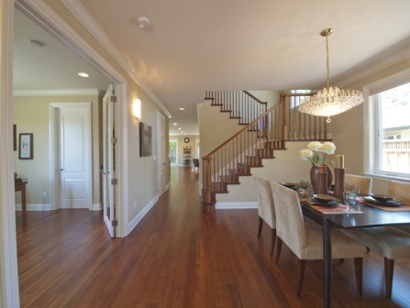
DINING ROOM
- Crystal chandelier
- Art glass wall sconces
- Double wide window
- Partial view of kitchen
- Hardwood stairs and railing
- Double glass doors to office (with blinds)
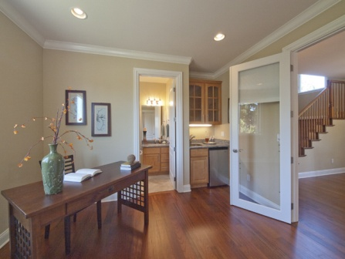
OFFICE
- Wet bar: granite counter top, stainless steel sink, mini-refrigerator, maple china cabinet, under cabinet lighting
- Double wide window view of side yard
- White raised panel door with leaded glass pane to front yard
- Double glass doors with blinds to hall/dining room.
- Closet with shelves and dividers
- Full bath

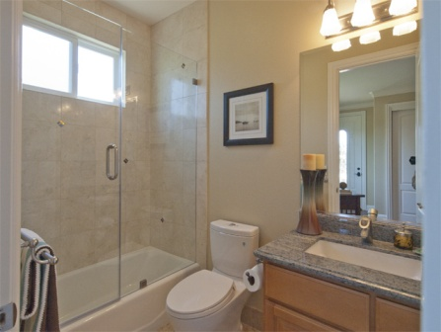
OFFICE BATH
- Stone tiled floor
- Granite vanity top, honey colored maple cabinet
- Triple satin wall light above mirror
- Stone tiled shower surround with small glass tile inserts
- Clear frameless shower doors
- Window at top of shower wall
- Satin towel racks and fixtures
- White Kohler tub
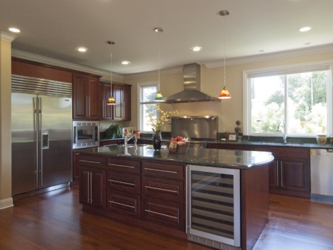
KITCHEN
- 4 by 8 foot island
- Green stone counter tops
- Reddish brown mahogany cabinets
- Two separate sinks. Island sink with instant hot water
- Two door SubZero refrigerator with water/ice dispenser
- Stainless steel Sharp convection oven
- Professional grade Thermador range with two ovens, griddle, and grill
- Stainless steel hood over range
- Pot filler at range
- Single wide window above counter
- Double wide window above sink
- 3 art glass pendants hanging over island
- Wine cooler
- Miele dishwasher
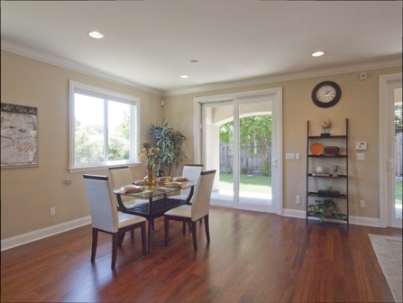
GREAT ROOM
- Large enough for informal dining and family room
- Two sliding doors to covered, slate tiled patio
- Glass paneled door to side yard with blinds between double panes
- Art glass accent pendant / reading light
- Half Bath
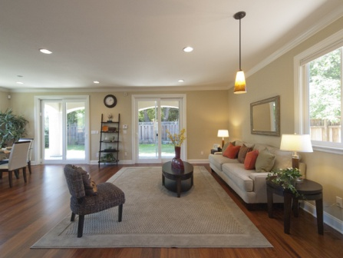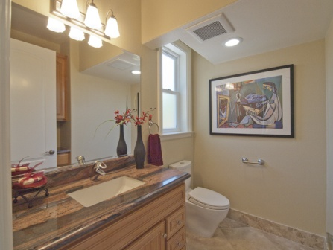
HALF BATH
- Reddish stone counter top on beaded maple vanity
- Beveled glass mirror
- Satin finished towel ring
- Separate built-in cabinet with 8 drawers and stone counter top
- Stone tiled floor with glass tile accents
- Frosted window
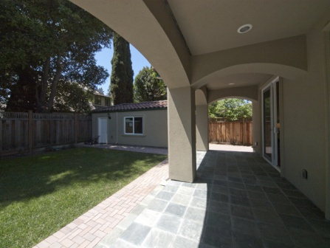
PATIO
- Green-grey slate tiles
- Covered by second story, recessed lights
- Multiple arched passages to back yard
GARAGE
- Double wide side window
- Side door
- Electric garage door
- Would make an ideal gardening room or work shop

STAIRWAY
- Double high window
- Recessed lighting and chandelier hook
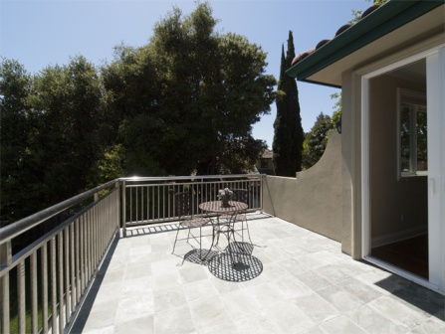
MASTER BEDROOM
- Walk-in closet with frosted window
- Slate tiled balcony
- Glass sliding doors to balcony
- Picture window flanked by sliding panes
- Coax & telephone connections
SECOND BEDROOM
- Full bath
- Walk in closet
- Balcony
- Pie pan ceiling
- Coax & telephone connections
SECOND BEDROOM BATH
- Purple, green, grey counter on maple vanity
- Stone tiled shower surround over tub with glass tile accents and stone shelf
- Frameless clear glass shower doors
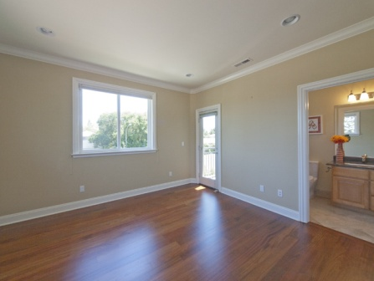
THIRD BEDROOM
- Door to hall bath
- Balcony sheared with second bedroom
- Windows on two walls
- Closet with shelves and dividers
- Coax and telephone connections
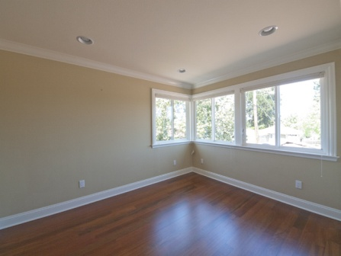
FOURTH BEDROOM
- Glass windowed corner
- Closet with shelves and dividers
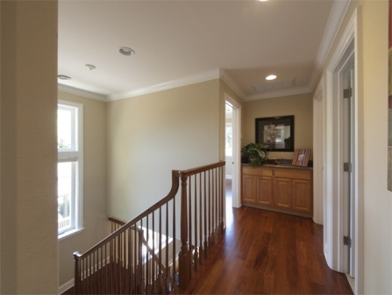
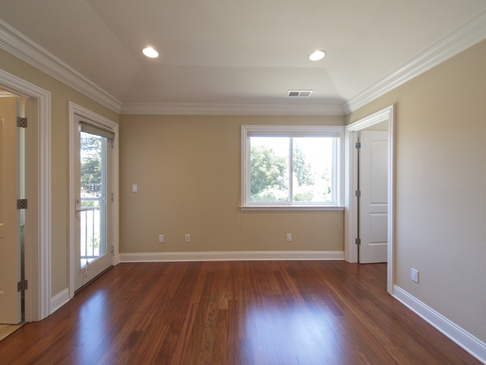
UPSTAIRS HALL
- Built in maple cabinet with reddish stone counter top
- Upstairs thermostat
SYSTEMS
- Central forced air heat and air conditioning with thermostats on both floors
- Security system
- Sprinklers
SCHOOLS
- Juana Briones Elementary
- Terman Middle
- Gunn High

